Climate change - the danger from above?!

Here are two short texts about the climate change. Read through them and then work on the exercises.
TEXT A
The report by Dr David Viner and Dr Maureen Agnew, scientists at the University of East Anglia, looks at how climate change will have an effect on world tourism.

As the temperature rises, Southern Spain may become a habitat for the mosquitoes that carry malaria. Greece and Turkey may become too hot to be comfortable, with temperatures above 40 C.

As the sea level rises, too, the Maldives, a beautiful group of islands in the Indian Ocean, some of them less than 1 metre above sea level, are in danger of flooding.

Winter holidays will be harmed, too. If the warming trend continues, the snow season in the Alps could become shorter and there will be less snow when it does fall. Speaking to the Daily Telegraph, Dr Viner said: “Climate change is going to hit hard in places that people in the United Kingdom are fond of visiting.

Areas like the Mediterranean¹, a popular place for British tourists, could become too hot during the traditional summer holiday season.”

2003 has been the hottest year so far. Every 10 years, temperatures will nearly rise between 0.2 and 0.3 degrees Celsius and sea levels up to 10 centimetres.

While some experts say that changes may not be as dramatic as the report claims, Dr Ute Collier, head of the climate change at WWF (Worldwide Fund of Nature), recommends: “We must take action to solve the problem of global climate change now,” she said.

¹ Mediteranean - Mittelmeerländer
1
2
3
4
5
6
TEXT B
Ozone is a kind of oxygen. You can smell it near a photocopying machine. But don’t breathe it in – it is dangerous. But about 20 to 40 kilometres above our heads there is a layer of ozone protecting us from ultraviolet sunlight, which would destroy all life on Earth. However, this ozone layer is getting thinner – it is being damaged by chemicals such as CFCs in sprays and fridges. There is a hole in the ozone layer which opens up over part of Australia in the spring. As the hole grows, so does the danger. 90% of Australian high school pupils have problems with their skin. It is an especially big problem there because most Australians have fair hair and skin. In 2002 almost 300,000 Australians had one or more skin cancers removed. The use of CFCs has been reduced, but more action to protect the ozone layer is urgently needed because of the chemicals that survive in the atmosphere. Australia is now taking action to reduce and abolish ozone-eating chemicals but the situation won’t improve before 2050 – if it does at all.

Name: 22nd November 2004 10a
1st Written Test in English
score: mark:
TEXT A
1. True, False or not in the text (NIT)? TRUE FALSE NIT 4
1.1 Global warming will influence tourism. ☺ ☹ 😐
1.2 Some of the Maldives’ islands could be under water soon. ☺ ☹ 😐
1.3 In summer a lot of British people go to countries like Italy or Spain. ☺ ☹ 😐
1.4 While the sea levels are getting lower, temperature levels are rising. ☺ ☹ 😐

2. Four sentences have been removed from the text. Choose the best position in the report. 4

2.1 This would also be the cause for more smog in big cities such as Athens.

2.2 And if it’s too hot, or there is a risk of strange diseases, tourists will stay away.

2.3 Florida and the rest of the south-east coast of the US could also suffer floods.

2.4 Global warming is increasing, the report says.

TEXT B
3. One ending to the following sentences is correct. Tick it! 3
3.1 Ozone is ( ) good ( ) bad ( ) good and bad for the people.
3.2 In spring parts of Australia are open to ( ) oxygen ( ) ultraviolet light ( ) CFCs.
3.3 A lot of chemicals ( ) are stored ( ) are killed ( ) are reduced in the atmosphere.

TEXT A/ TEXT B
4. Read the statements and decide which text they are about. Then write A for TEXT A or B for TEXT B. 5
4.1The health of many people has already been destroyed.
4.2 Not everybody regards the problem to be that terrible.
4.3 The hole is already three times the size of Australia.
4.4 If you get a sun-burn easily, you are at a higher risk.
4.5 If you want to have a nice summer holiday in a hot country, you should go there soon.

5. Find synonyms for the words in brackets. 4
5.1 Winter holidays will be _______________________ (>> harmed).
5.2 People in the United Kingdom _____________________ (>> are fond of) visiting holiday places.
5.3 Temperatures will __________________ (>> nearly) rise between 0.2 and 0.3 degrees Celsius.
5.4 Most Australians have __________________ (>> fair) hair.

6. Paraphrase the underlined words. Do not change the meaning.
6.1 If __________________________________________________________________________1/1
If the warming trend continues … (line 7)

6.2 As the hole __________________________________________________________________ 1/1
As the hole grows, so does the danger. (line 6)

6.3 Australia is __________________________________________________________________2/1
Australia is taking action to reduce ozone-eating chemicals (line 11)

7. Use words from the same word families to complete the sentences. 3
7.1 We must think about a _________________ (solve) to the problem,” Dr Ute Collier said.

7.2 The __________________ (protect) ozone layer above our heads will soon be destroyed.
7.3 The ___________________ (destroy) of the ozone layer by chemicals is a big problem.

8. Explain the meaning of the words in complete sentences.
8.1 habitat (line 3): ___________________________________________________________________
_______________________________________________________________________________1/1
8.2 tourist (line 11): _________________________________________________________________
_______________________________________________________________________________1/1

Grammar
9. Make the participle sentences longer. You might have to add a word.
9.1 After studying history at Cambridge University, Dr Viner got a job as a scientist. 2
__________________________________________________________________________________________________________________________________________________________________
9.2 Seeing the dangers of pollution, he organizes environmental campaigns. 2
__________________________________________________________________________________________________________________________________________________________________

10. Now shorten the sentences and use a participle.
10.1 When he talked to Maureen Agnew, Dr Viner saw she had the same opinions. 1
_________________________________________________________________________________
10.2 Because she was asked by Dr Viner, Mrs Agnew supported his work. 1
_________________________________________________________________________________

11. Mixed grammar 13
Dr Viner, a scientist __________________________ (work) for the University of East Anglia _______________ (say) yesterday: “____________ (?) my opinion alternative sources of energy are the _______________ (good) way _____________________ (provide) enough energy. The electricity __________________ (produce) by tidal power is not only cheaper but also ____________________ (effective), too. We must change our lifestyle now, or the damage ___________ (?) has already been _______________ (do) to our environment cannot _______________________ (repair). What I mean is that so far the air, rivers, lakes and the seas __________________________________ (pollute) by billions of tons of chemical waste and if we go on harming the earth, the danger of horrible natural disasters where lots of people will lose their __________________ (?) _______________________ (become) bigger in the next years.

12. Translate into good German.
12.1 One has to admit that the burning of fossil fuels has influenced both people’s health and the
climate in a very bad way. 3
___________________________________________________________________________________________________________________________________________________________________________________________________________________________________________________
12.2 This has been proved in many enquiries. 2
_________________________________________________________________________________
12.3 Australia generates most of its electricity from coal power stations. 2
_________________________________________________________________________________
12.4 According to many people alternative forms of energy such as hydroelectric or solar power must
as soon as possible be used on a large scale. 4
___________________________________________________________________________________________________________________________________________________________________________________________________________________________________________________
12.5 They are renewable, can easily be stored for future use and don’t pollute the environment as coal
or gas do. 3
___________________________________________________________________________________________________________________________________________________________________________________________________________________________________________________
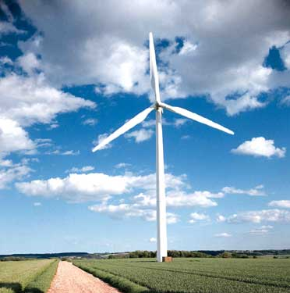
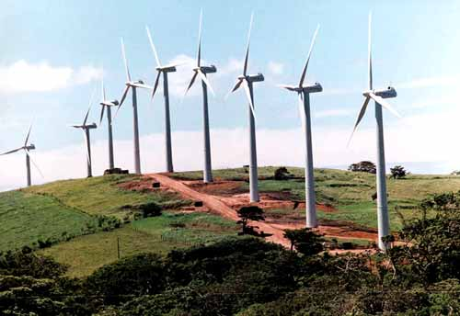

13. Guided Writing
You are an exchange student in Australia and have just read in your local newspaper that the government is planning to build a wind park close to your village, Wellville. Her is part of the article.
Write a letter of about 120 words to the editor and use the given prompts. 8/4/4
Yesterday’s news report about the Australian government’s decision to build a wind park with 50 turbines near Wellville has caused a storm of protest. “Building these wind turbines near our village is absolutely impossible. We can’t let this happen!” said Molly Walker, speaker of the local Greenpeace group.
reactions in your host family
suitable beginning/ ending
your opinion about wind power
noise problem
other suggestion:
other form of alternative energy
_________________________________________________________________________________
_______________________________________________________________________________________________________________________________________________________________________________________________________________________________________________________________________________________________________________________________________________________________________________________________________________________________________________________________________________________________________________________________________________________________________________________
_______________________________________________________________________________________________________________________________________________________________________________________________________________________________________________________________________________________________________________________________________________________________________________________________________________________________________________________________________________________________________________________________________________________________________________________
_______________________________________________________________________________________________________________________________________________________________________________________________________________________________________________________________________________________________________________________________________________________________________________________________________________________________________________________________________________________________________________________________________________________________________________________
_________________________________________________________________________________
_________________________________________________________________________________
Good luck!

