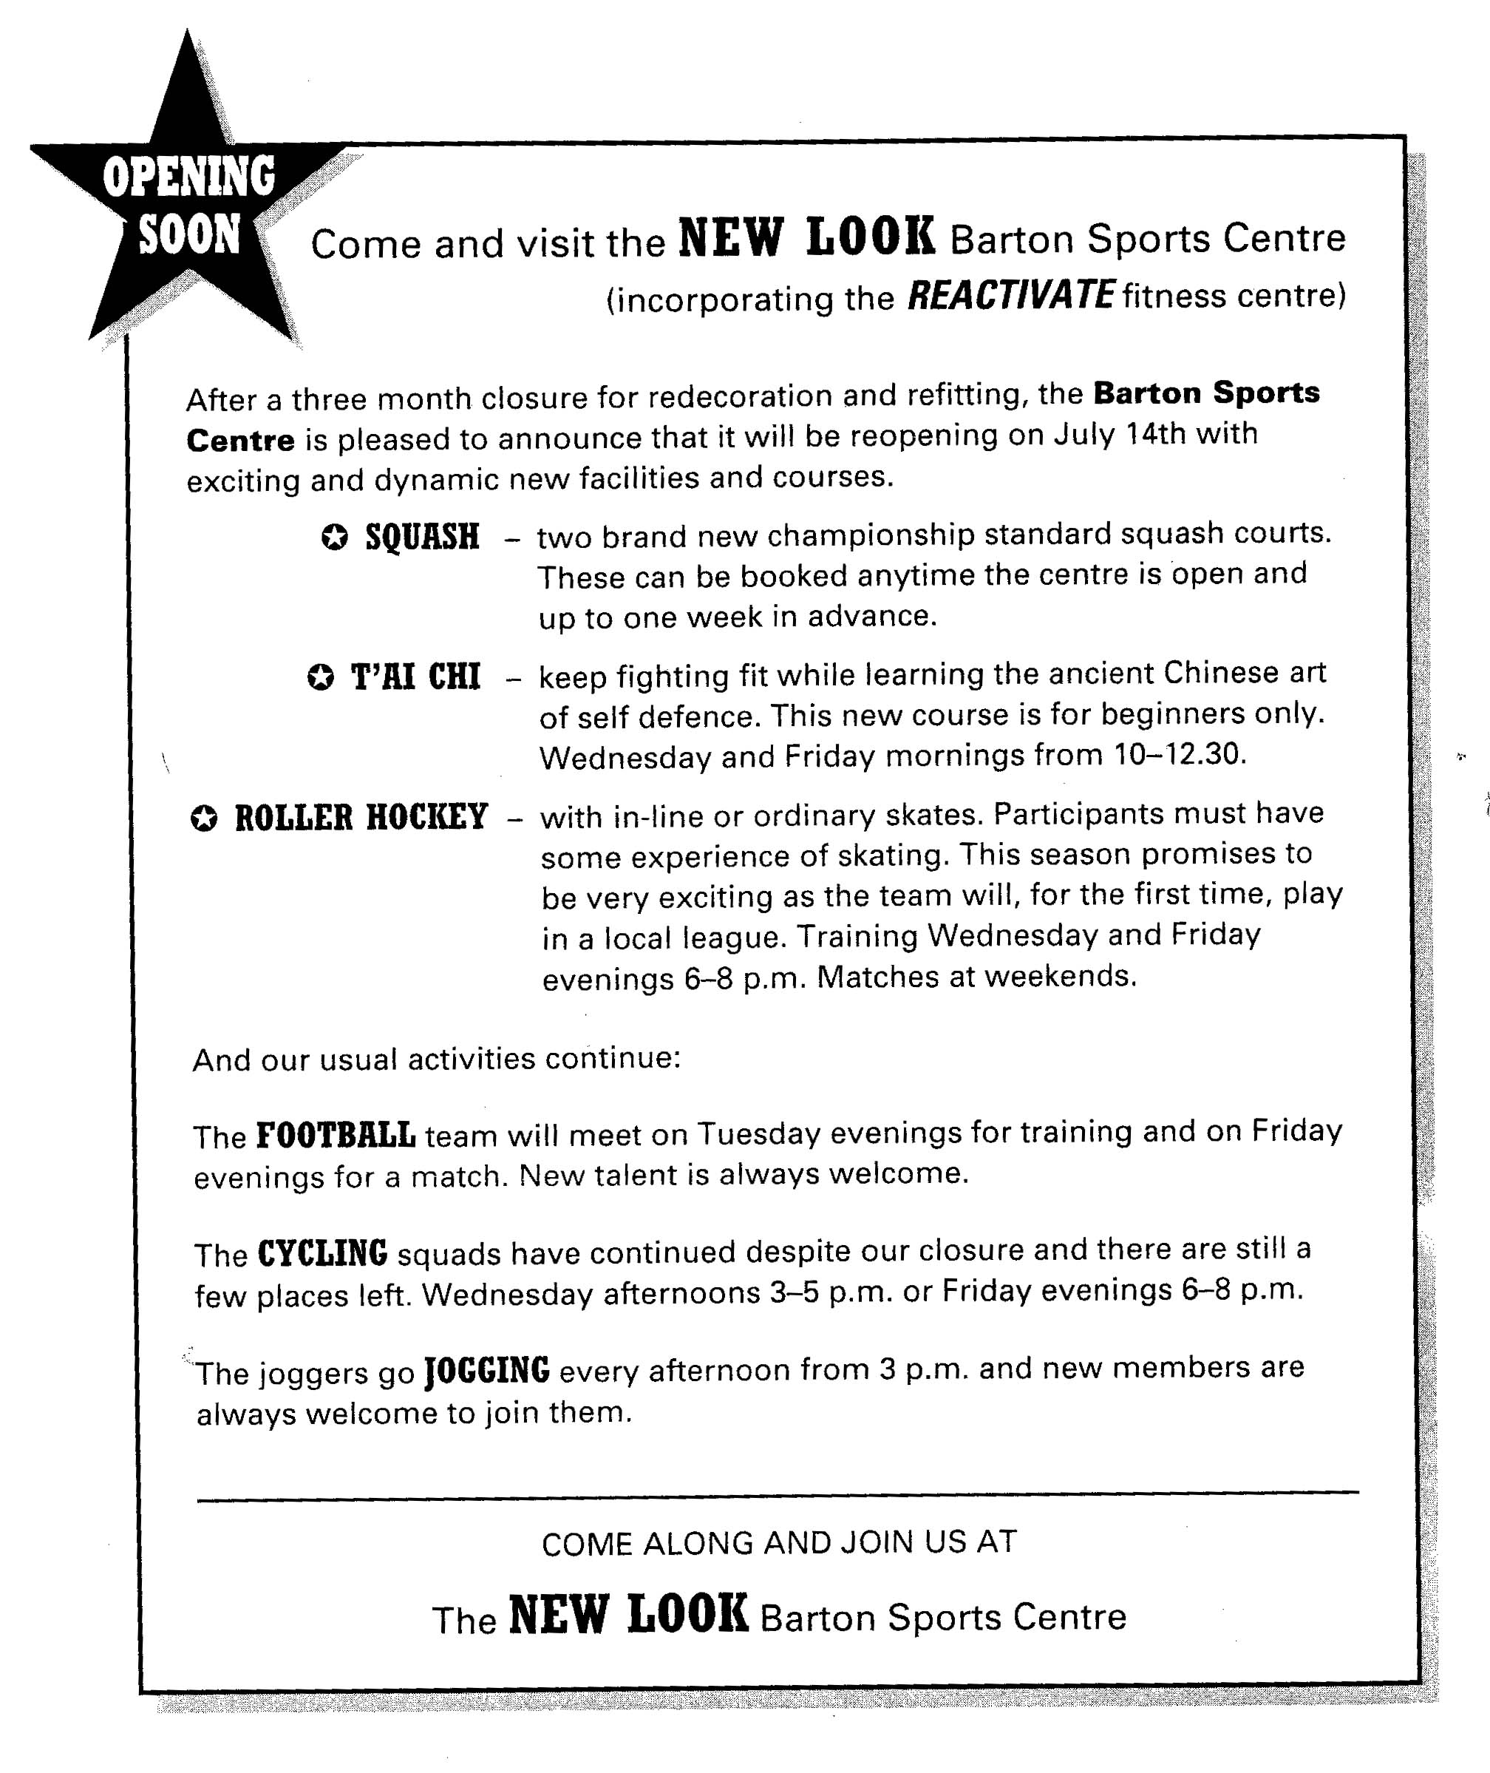

New Look
Use the information printed above (a leaflet about a new sports centre) to answer the following questions. Do not write full sentences.

1. Where is the Reactivate fitness centre? 1
_______________________________________________________________________
2. When will the Barton Sports Centre be open again? 1
_______________________________________________________________________
3. When is the earliest chance to reserve squash courts? 1
_______________________________________________________________________
4. Who can take part in T’ai Chi? 1
_______________________________________________________________________
5. How many hours a week is the T’ai Chi course? 1
_______________________________________________________________________
6. Can you take part in Roller hockey if you have never played it before? 1
_______________________________________________________________________
7. How many times has the hockey team played in the local league before? 1
_______________________________________________________________________
8. When are the hockey games? 1
_______________________________________________________________________
9. Does the football team need new members? 1
_______________________________________________________________________
10. Which teams train on Friday evenings? 2
_______________________________________________________________________
11. Who trains every day? 1
_______________________________________________________________________
12. Which two new activities are there at the sports club? 2
_______________________________________________________________________

